Dear Sisters and Brothers, 25 October, 2017
Do you remember, back in the good ol’ days when we would have our class of instruction (fondly known as the All Member Workshop) on Saturday after Grand Installation? Yeah, we don’t do that anymore. I would like to turn this situation into an excuse to party!
You are cordially invited (encouraged, cajoled, pleaded with, etc.) to attend the

All Member, Secretary/Treasurer, Conductress,
Santa’s Workshop, Luncheon and Party!

Here’s how it works:
Everybody come to the Midvale Masonic Hall on 16 December at 10:00 am. We will hold the all member workshop first. Then we will break for a $5 lunch of soup and salad. After that, we will have a gift exchange ($10 or less) for those who want to play. It will almost certainly be “Dirty Santa” so keep that in mind when choosing a gift! After the fun and games are over, the Conductresses will retire upstairs and the Secretaries and Treasurers will meet downstairs for their respective instruction.
I hope to see every one of you there!
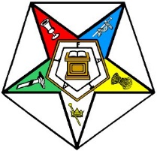
Yours in Faith and Service,
Jim Sweet
Tammie Chance

Tammie Chance, Jim Sweet,
Worthy Grand Matron Worthy Grand Patron

Karen Pullman

Karen B. Pullman,
Grand Secretary

